Prompt evaluation
✅ Simple Definitions
🔹 Prompt Engineering
👉 “AI ko sahi tarah se question puchna”
(Asking the AI clearly and properly)
🔹 Prompt Evaluation
👉 “AI ka answer sahi hai ya nahi check karna”
(Checking if the AI’s answer is good or not)
✅ Easy Definitions
🔹 Prompt Engineering
👉 Asking the AI the right way to get a good answer
🔹 Prompt Evaluation
👉 Checking if the AI’s answer is good or not

🇮🇳 Simple Example
1. Prompt Engineering (How you ask)
You ask:
👉 “Explain GST in simple words in 3 points.”
✔ Clear question = Better answer

2. Prompt Evaluation (Checking answer)
You check:
- Is it simple? ✅
- Only 3 points? ✅
- Easy to understand? ✅
✔ If yes → Good
❌ If not → Improve the question

🔄 Simple Summary
👉 Prompt Engineering = How you ask
👉 Prompt Evaluation = How you check

🧠 One-line trick
👉 “Ask clearly → Check answer → Improve” ✅
✅ Prompt Engineering vs Prompt Evaluation (Simple)
🔹 Prompt Engineering
👉 It means writing better prompts (questions/instructions)
- It helps the AI understand clearly what you want
- You use techniques like giving examples, clear steps, or format
✅ Simple meaning:
“How to write a good question for AI”

🔹 Prompt Evaluation
👉 It means checking how good your prompt actually is
- You test if the AI gives correct answers
- You compare different prompts
- You find mistakes in the output
✅ Simple meaning:
“How to check if your question is working well”
🔄 Simple Difference
- Prompt Engineering = Writing the question
- Prompt Evaluation = Checking the answer

🧠 One-line to remember
👉 “Write clearly → Test properly → Improve” ✅
✅ Three Options After Writing a Prompt
After you write a prompt, you have 3 choices:

🔹 Option 1: Test once and use it
👉 You try the prompt only one time and think it's working
❌ Problem:
- It may fail when real users give different inputs
- High risk in real-world use
👉 Simple meaning:
“Test once and assume it's correct”

🔹 Option 2: Test a few times and improve
👉 You test the prompt 2–3 times and fix small issues
✅ Better than Option 1
❌ Problem:
- You still may miss unexpected cases
- Not fully reliable
👉 Simple meaning:
“Test a few times and adjust”

🔹 Option 3: Use proper evaluation (Best way) ✅
👉 You test the prompt with many cases using a proper system
- Check scores and results
- Compare different versions
- Improve based on data
✅ Advantage:
- More accurate
- More reliable
- Works better in real situations
👉 Simple meaning:
“Test properly using data and improve step-by-step”

🔄 Final Simple Summary
- Option 1 → Quick but risky ❌
- Option 2 → Better but not perfect ⚠️
- Option 3 → Best and reliable ✅

🧠 One-line to remember
👉 “Don’t test once — test properly and improve” ✅
✅ Why Engineers Make Testing Mistakes
Most engineers choose Option 1 or 2 (quick or limited testing) because:
- We test only simple or obvious inputs
- We assume users will behave the same way
- But in reality, users give unexpected inputs
❌ Result:
The prompt works in testing but fails in real use

✅ The Solution (Best Practice)
👉 Use Option 3: Proper Evaluation
- Test with many different cases
- Check results using data (scores)
- Find problems early
- Improve step-by-step
✅ This makes your prompt more reliable

✅ Why Evaluation is Important
- You don’t guess → you measure
- You don’t assume → you test properly
- You improve with real data

🔄 Simple Flow
👉 Write prompt
👉 Test properly (many cases)
👉 Measure results
👉 Improve

🧠 Simple One-line Idea
👉 “Users will surprise you — so test more and test smart” ✅
A typical eval workflow
✅ Simple Prompt Evaluation Workflow
This is just a step-by-step way to test and improve your prompt

🔹 Step 1: Write a basic prompt -> Step 1: Draft Your Initial Prompt
👉 Start simple
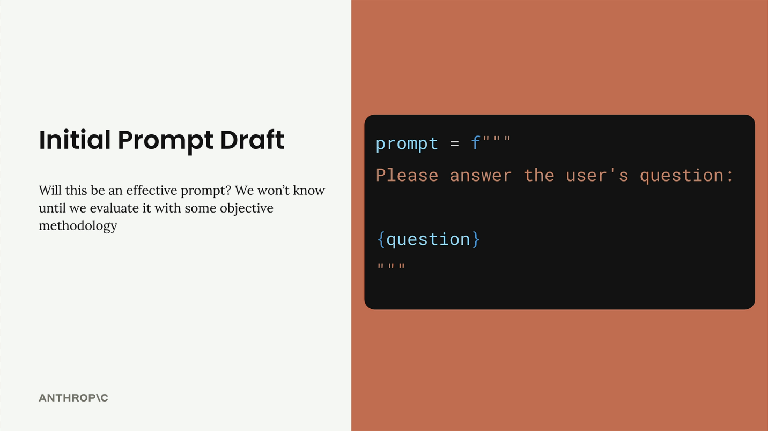
Example:
Please answer the user’s question:
{question}
👉 This is your starting point (baseline)

🔹 Step 2: Create test questions (dataset) -> Step 2: Create an Evaluation Dataset
👉 Prepare some sample inputs
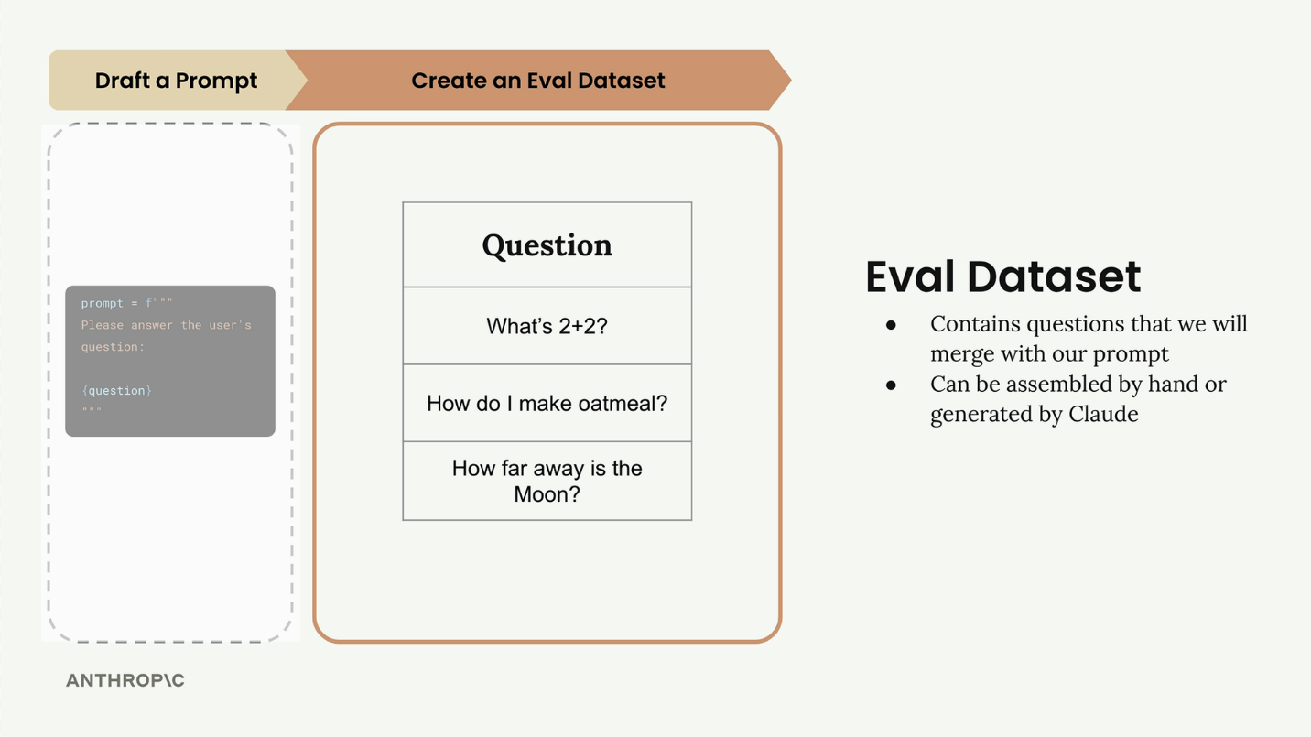
Example questions:
- What’s 2+2?
- How do I make oatmeal?
- How far is the Moon?
👉 These help you test your prompt properly

🔹 Step 3: Run prompt with each question -> Step 3: Feed Through Claude
👉 Combine prompt + question and send to AI
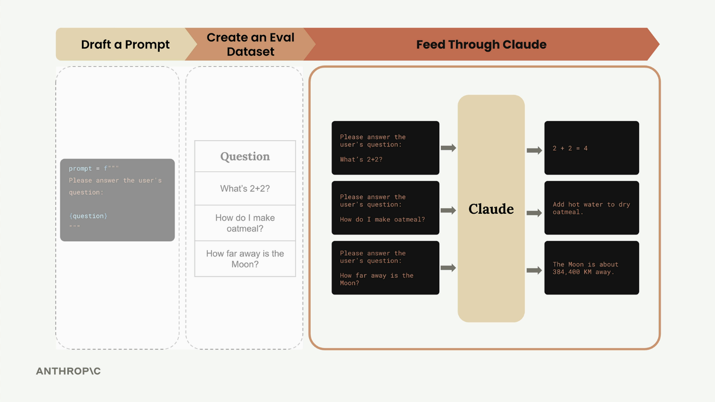
You will get answers like:
- 2 + 2 = 4
- Cooking steps
- Moon distance

🔹 Step 4: Score the answers (grading) -> Step 4: Feed Through a Grader
👉 Check how good each answer is
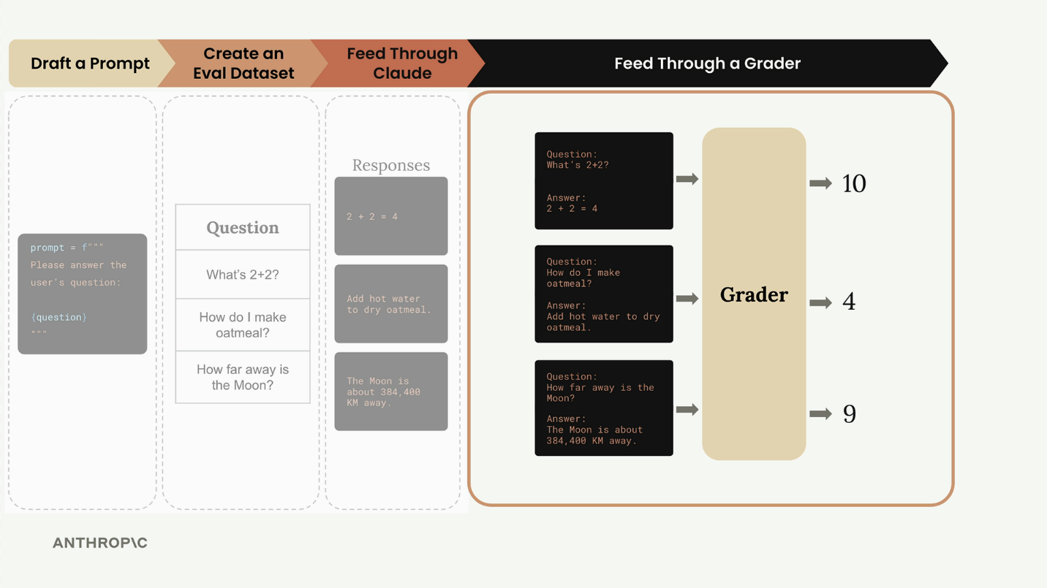
Example scoring:
- 10 = Perfect ✅
- 4 = Needs improvement ⚠️
- 1 = Bad ❌
👉 Then calculate average score
Example: 7.66

🔹 Step 5: Improve prompt and repeat -> Step 5: Change Prompt and Repeat
👉 Update your prompt
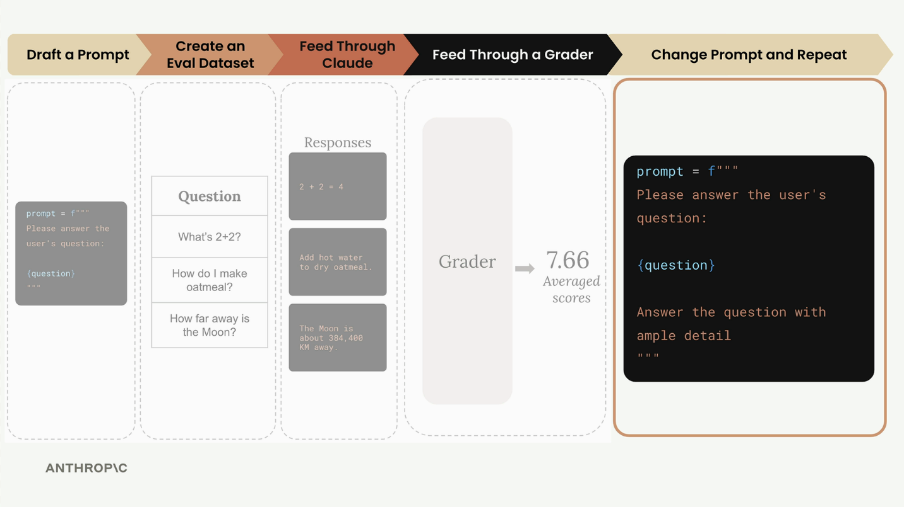
Example:
Please answer the user’s question:
{question}

Give a detailed answer
👉 Run all steps again and compare scores

Prompt Scoring and Iteration
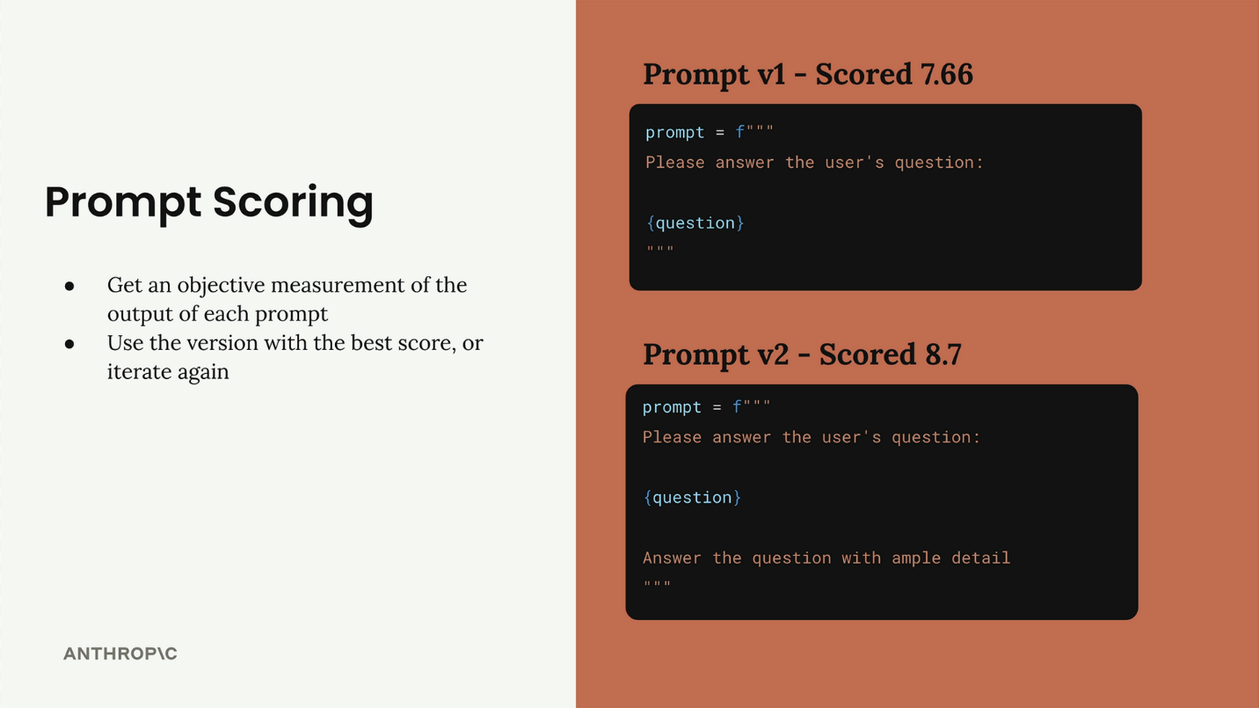
✅ Result (Example)
- Prompt V1 → Score: 7.66
- Prompt V2 → Score: 8.7 ✅
👉 Better prompt = Higher score

🔄 Simple Summary
👉 Write prompt
👉 Test with questions
👉 Check scores
👉 Improve
👉 Repeat

🧠 One-line idea
👉 “Test → Score → Improve → Repeat” ✅
Generating test datasets

Downloads
- dataset.json(opens in new tab)
- 001_Prompt_Evals.ipynb(opens in new tab)
- 001_Prompt_Evals_complete.ipynb
✅ Simple: Building a Prompt Evaluation Workflow
🔹 Goal (What we want) -> Setting Up the Goal
👉 Build a prompt that gives only code output
Types of output:
- Python code
- JSON
- Regex
❗ No explanations, no extra text — only code
The prompt should take a user's task description and return one of three output types:
- Python code
- JSON configuration
- Regular expressions
The key requirement is that responses should contain only the requested code without headers, footers, or explanations.

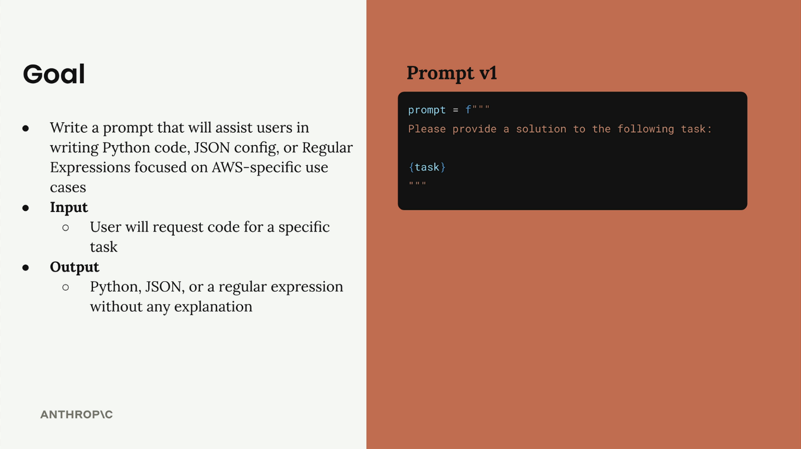
🔹 Step 1: Start with a simple prompt
👉 Keep it basic first
Please provide a solution to the following task:
{task}
👉 This is your first version (baseline)
Step2: Creating Evaluation Datasets
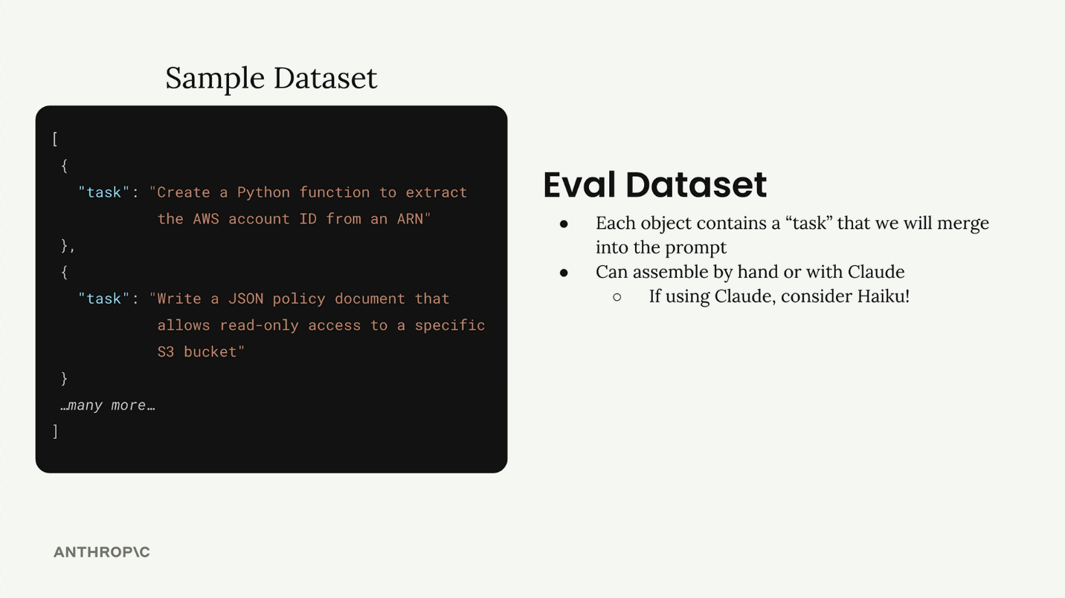

👉 Prepare some example tasks to test
Example:
- Write a Python function for AWS
- Create JSON for EC2 config
- Write regex for S3 bucket name
👉 You can create:
- Manually ✅
- Or automatically using AI ✅
For automatic generation, using a faster model like Haiku makes sense since you're generating multiple test cases.
🔹 Step 3: (Optional) Generate test data using AI -> Generating Test Data with Code
👉 Use AI to create multiple test cases
Example idea:
- Ask AI: “Give 3 AWS tasks needing Python, JSON, or Regex”
👉 Save results in JSON format
def generate_dataset():
prompt = """
Generate 3 AWS-related tasks that require Python, JSON, or Regex solutions.

Focus on tasks that can be solved by writing a single Python function,
a single JSON object, or tasks that do not require writing much code.

Example output:
[
{
"task": "Description of task"
},
...additional
]

Please generate 3 objects.
"""

messages = []
add_user_message(messages, prompt)
add_assistant_message(messages, "```json")
text = chat(messages, stop_sequences=["```"])
return json.loads(text)
✅ Example Output (What you get)
After running:
dataset = generate_dataset()
👉 You might get:
[
{
"task": "Write a Python function to list all S3 buckets"
},
{
"task": "Create a JSON configuration for an EC2 instance"
},
{
"task": "Write a regex to validate an AWS ARN"
}
]

🔹 Step 4: Save your dataset
👉 Store the test cases so you don’t repeat work
Example:
dataset.json
👉 Helps in reusing and scaling later
dataset = generate_dataset()
with open("dataset.json", "w") as f:
json.dump(dataset, f, indent=2)

🔹 Step 5: Use dataset for evaluation
👉 Run your prompt with each task
Check:
- Did it return only code? ✅
- Any extra explanation? ❌
- Correct output type? ✅

✅ Why this is useful
- You test with real scenarios
- You catch mistakes early
- You improve your prompt step by step

🔄 Simple Summary
👉 Define goal
👉 Create test cases
👉 Run prompt
👉 Check output
👉 Improve prompt

🧠 One-line idea
👉 “Set goal → Test with real tasks → Improve prompt” ✅
Running the eval
✅ What is happening here (Simple Idea)
👉 Now you already have test data (dataset)
👉 Next step is to test your prompt on all those cases
This process is called evaluation pipeline
✅ Overall Flow (Big Picture)
👉 Take test case
👉 Add it to prompt
👉 Get AI output
👉 Score it
👉 Store result
✅ 3 Main Functions (Super Simple)
🔹 1. run_prompt() → Run the prompt
def run_prompt(test_case):
👉 Takes one test case
prompt = f"""
Please solve the following task:

{test_case["task"]}
"""
👉 Combines:
- Prompt + task
messages = []
add_user_message(messages, prompt)
output = chat(messages)
👉 Sends to AI and gets response
return output
👉 Returns AI answer
def run_prompt(test_case):
"""Merges the prompt and test case input, then returns the result"""
prompt = f"""
Please solve the following task:

{test_case["task"]}
"""

messages = []
add_user_message(messages, prompt)
output = chat(messages)
return output
✅ Simple meaning:
👉 “Give task to AI and get output”
The run_test_case Function
This function orchestrates running a single test case and grading the result:
def run_test_case(test_case):
"""Calls run_prompt, then grades the result"""
output = run_prompt(test_case)

# TODO - Grading
score = 10

return {
"output": output,
"test_case": test_case,
"score": score
}
For now, we're using a hardcoded score of 10. The grading logic is where we'll spend significant time in upcoming sections, but this placeholder lets us test the overall pipeline structure.
✅ Simple meaning:
👉 “Run one test and save result”
The run_eval Function
This is the main orchestrator that processes the entire dataset:
def run_eval(dataset):
"""Loads the dataset and calls run_test_case with each case"""
results = []

for test_case in dataset:
result = run_test_case(test_case)
results.append(result)

return results
This function loops through every test case in our dataset, processes each one, and collects all the results into a single list.
Running the Evaluation
To execute our evaluation pipeline, we load the dataset and call our main function:
with open("dataset.json", "r") as f:
dataset = json.load(f)

results = run_eval(dataset)
The first time you run this, expect it to take some time - even with Claude Haiku, processing a full dataset can take 30+ seconds. We'll cover optimization techniques later, but for now, patience is key.
Examining the Results
Once the evaluation completes, you can inspect the results with formatted JSON output:
print(json.dumps(results, indent=2))
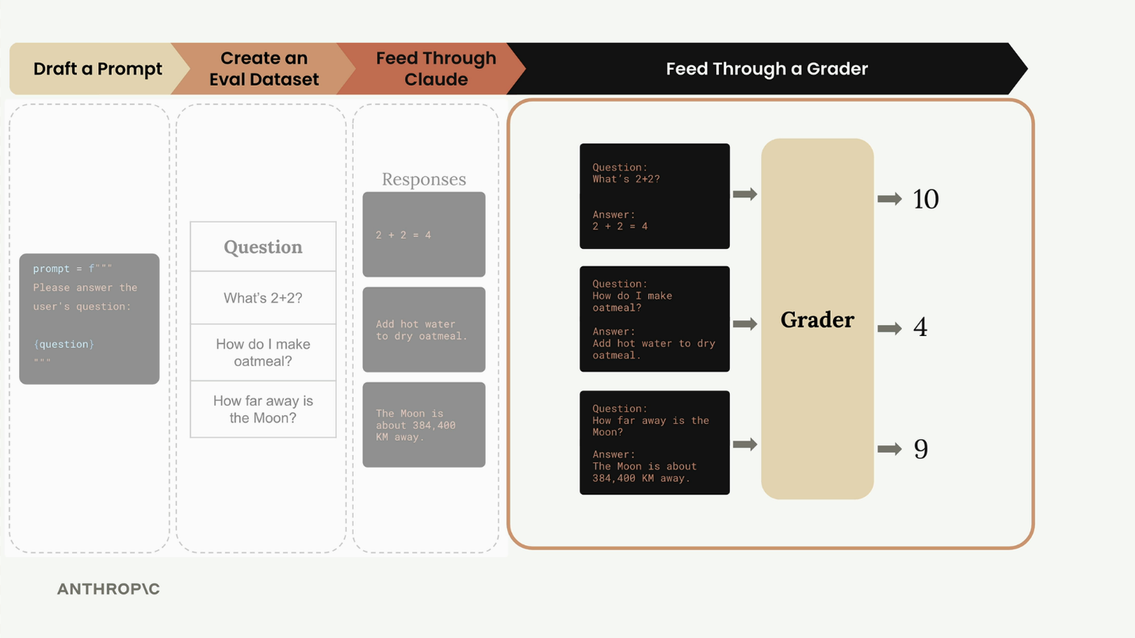
What We've Accomplished
At this point, we've successfully implemented the core evaluation pipeline. We can:
- Take test cases from our dataset
- Merge them with prompt templates
- Get responses from Claude
- Collect and organize all the results
Model based grading
Graders in prompt evaluation workflows help measure output quality by assigning a score, typically from 1 (low quality) to 10 (high quality).
Types of Graders:
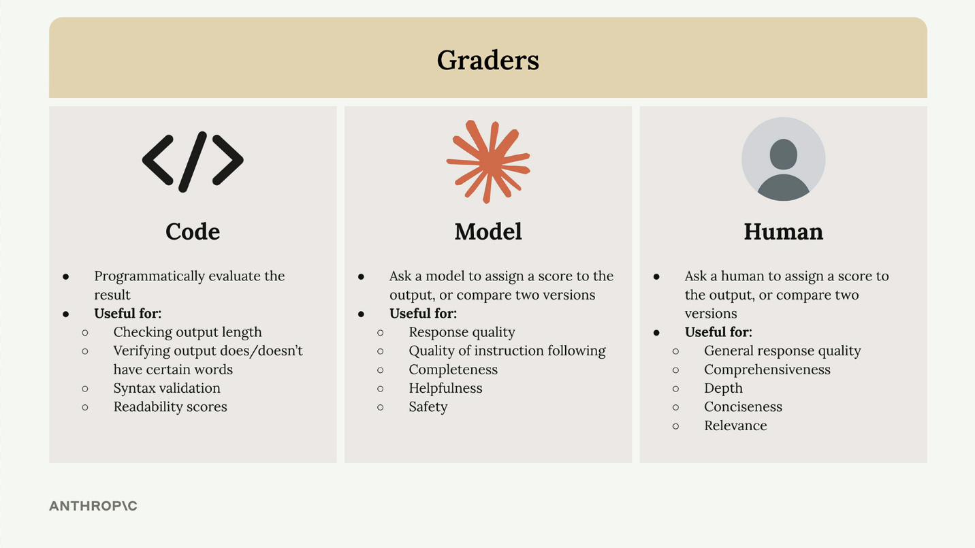
There are three main approaches to grading model outputs:
- Code graders - Programmatically evaluate outputs using custom logic
- Model graders - Use another AI model to assess quality
- Human graders - Have people manually review and score outputs
Code Graders
Code graders let you implement any programmatic check you can imagine. Common uses include:
- Checking output length
- Verifying output does/doesn't have certain words
- Syntax validation for JSON, Python, or regex
- Readability scores
The only requirement is that your code returns some measurable signal when it runs.
Model Graders
Model graders make an additional API request to evaluate the original output. This approach offers tremendous flexibility for assessing:
- Response quality
- Quality of instruction following
- Completeness
- Helpfulness
- Safety
Human Graders
Human graders provide the most flexibility but are time-intensive and tedious. They're useful for evaluating:
- General response quality
- Comprehensiveness
- Depth
- Conciseness
- Relevance

Defining Evaluation Criteria
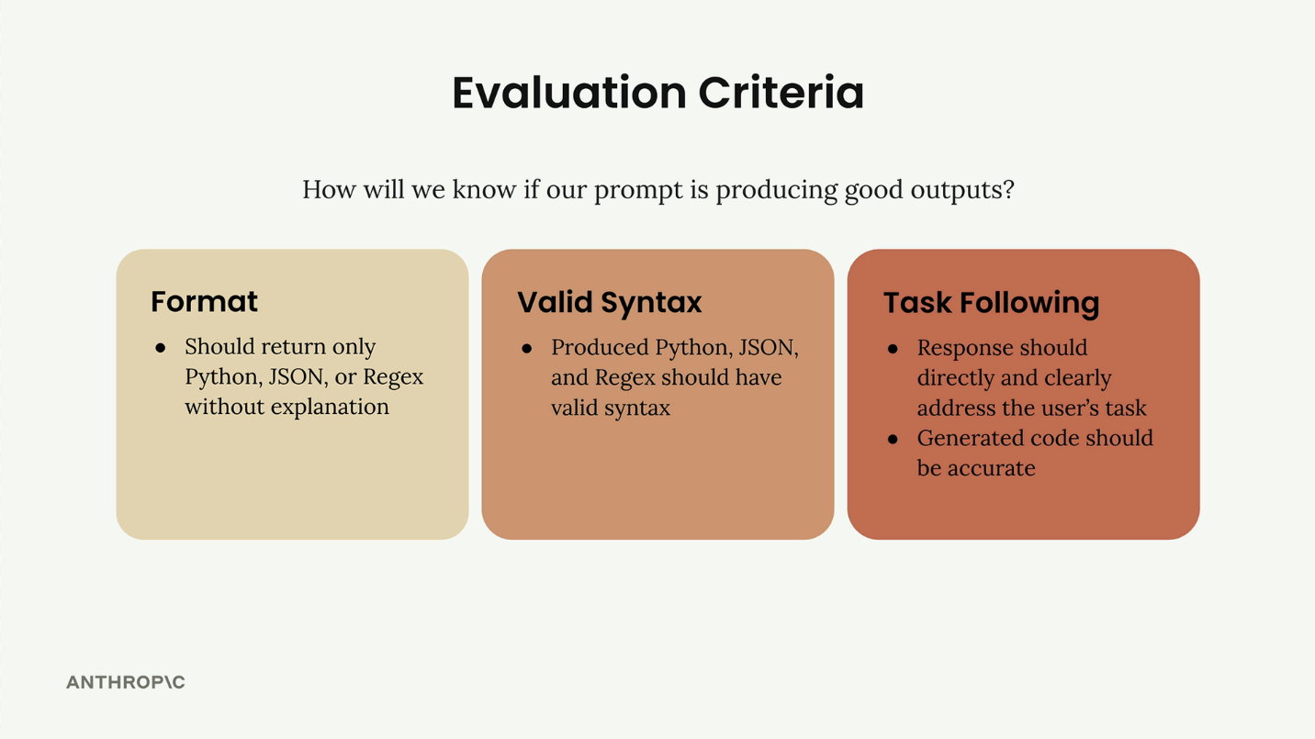
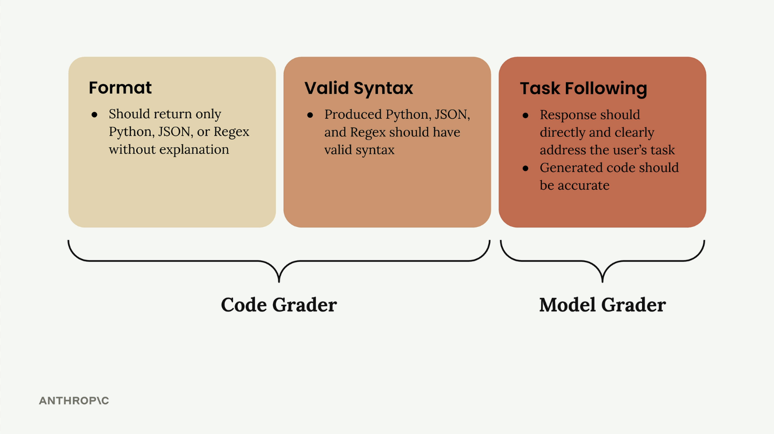
Implementing a Model Grader
Here's how to build a model grader function:
def grade_by_model(test_case, output):
# Create evaluation prompt
eval_prompt = """
You are an expert code reviewer. Evaluate this AI-generated solution.

Task: {task}
Solution: {solution}

Provide your evaluation as a structured JSON object with:
- "strengths": An array of 1-3 key strengths
- "weaknesses": An array of 1-3 key areas for improvement
- "reasoning": A concise explanation of your assessment
- "score": A number between 1-10
"""

messages = []
add_user_message(messages, eval_prompt)
add_assistant_message(messages, "```json")

eval_text = chat(messages, stop_sequences=["```"])
return json.loads(eval_text)
The key insight is asking for strengths, weaknesses, and reasoning alongside the score. Without this context, models tend to default to middling scores around 6.
Integrating the Grader
Update your test case function to use the model grader:
def run_test_case(test_case):
output = run_prompt(test_case)

# Get model evaluation
model_grade = grade_by_model(test_case, output)
score = model_grade["score"]
reasoning = model_grade["reasoning"]

return {
"output": output,
"test_case": test_case,
"score": score,
"reasoning": reasoning
}
Calculating Average Scores
To get an overall performance metric, calculate the average score across all test cases:
from statistics import mean

def run_eval(dataset):
results = []

for test_case in dataset:
result = run_test_case(test_case)
results.append(result)

average_score = mean([result["score"] for result in results])
print(f"Average score: {average_score}")

return results
This gives you a concrete, objective metric to track prompt performance over time. While model graders can be somewhat inconsistent, they provide a starting point for measuring and improving your prompts systematically.
Code based grading
Code-based grading adds an extra layer of validation to your prompt evaluations by checking whether the model's output follows the correct format and has valid syntax. This is especially useful when you're asking models to generate code, JSON, or regular expressions.
How Code Grading Works
The code grader evaluates two main criteria:
- Format compliance - Does the output contain only the requested format (Python, JSON, or regex) without explanations?
- Valid syntax - Can the output actually be parsed or compiled successfully?
The system uses separate validation functions for each format type. If the code parses successfully, it gets a perfect score of 10. If parsing fails with an error, it gets a score of 0.
Setting Up Validation Functions
You'll need three helper functions to validate different output types:
def validate_json(text):
try:
json.loads(text.strip())
return 10
except json.JSONDecodeError:
return 0

def validate_python(text):
try:
ast.parse(text.strip())
return 10
except SyntaxError:
return 0

def validate_regex(text):
try:
re.compile(text.strip())
return 10
except re.error:
return 0
These functions use Python's built-in parsing capabilities to check syntax validity. The json.loads() function validates JSON, ast.parse() creates a Python abstract syntax tree, and re.compile() validates regular expressions.
Adding Format Information to Test Cases
Your test dataset needs to specify the expected output format for each task. Update your dataset generation prompt to include a format field:
{
"task": "Description of task",
"format": "python"
}
The format field should contain "json", "python", or "regex" depending on what type of output you expect from that particular task.
Improving Your Prompt
To get better results from the code grader, make your prompt instructions more specific:
* Respond only with Python, JSON, or a plain Regex
* Do not add any comments or commentary or explanation
You can also use a pre-filled assistant message with code blocks and stop sequences to ensure clean output formatting.
Combining Scores
The final step is merging your model grader score with the syntax grader score. A simple approach is to take the average of both scores:
model_grade = grade_by_model(test_case, output)
model_score = model_grade["score"]
syntax_score = grade_syntax(output, test_case)

score = (model_score + syntax_score) / 2
This gives equal weight to both content quality (from the model grader) and technical correctness (from the code grader). You can adjust this weighting based on what matters more for your specific use case.
Quiz on Prompt Evaluations
You need test data for evaluating your prompt. You want to create realistic examples quickly without writing them all by hand. What's the best approach?
Use Claude to automatically generate test cases
You've written a prompt for Claude and want to know if it works well. What's the difference between prompt engineering and prompt evaluation?
Prompt engineering writes better prompts, prompt evaluation measures how well they work
In prompt evaluation, what is a "grader" used for?
To give objective scores measuring output quality
You just wrote a prompt for your app. You test it once and it works great, so you decide to use it. What's the main risk with this approach?
Users will provide unexpected inputs that break it
You're running a prompt evaluation. After creating your dataset and feeding questions through Claude, what's the next step?
Feed the responses through a grader to get scores
You're using another AI model to evaluate Claude's responses. To get better scores than just random numbers around 6, what should you ask the grader to provide?
Strengths, weaknesses, reasoning, and a score
You want to check if Claude's output contains certain keywords and has the right length. Which type of grader should you use?
Code grader

